**PART-B**

|  |  |
| --- | --- |
| **Roll No.:**K041 | **Name:** Anish Sudhan Nair |
| **Prog/Yr/Sem:** B.Tech. Cybersecurity | **Batch:** K2/A2 |
| **Date of Experiment:** 04/02/2022 | **Date of Submission:** 11/02/2022 |

Functions , Events and Arrays

1. Write a Program to display Exponent of a two numbers using a JavaScript functions.

Code:

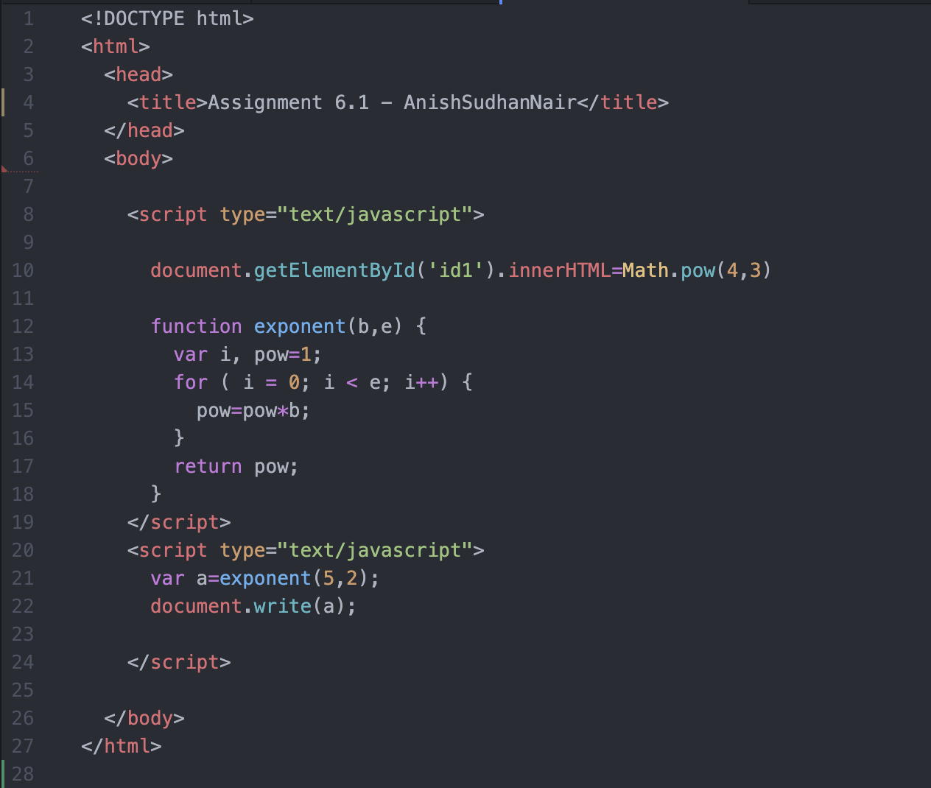

Output:

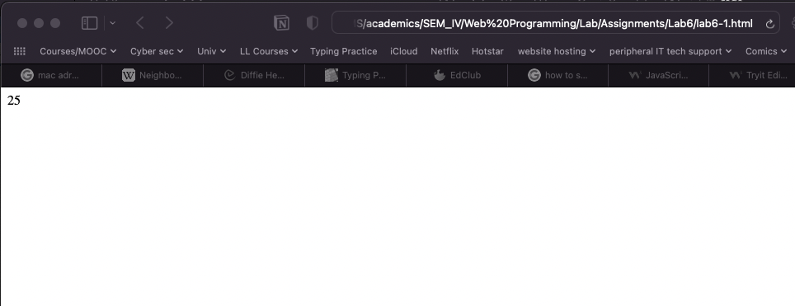

2. Write a Program to display a Moon weight and input will be actual earth weight .

Code:

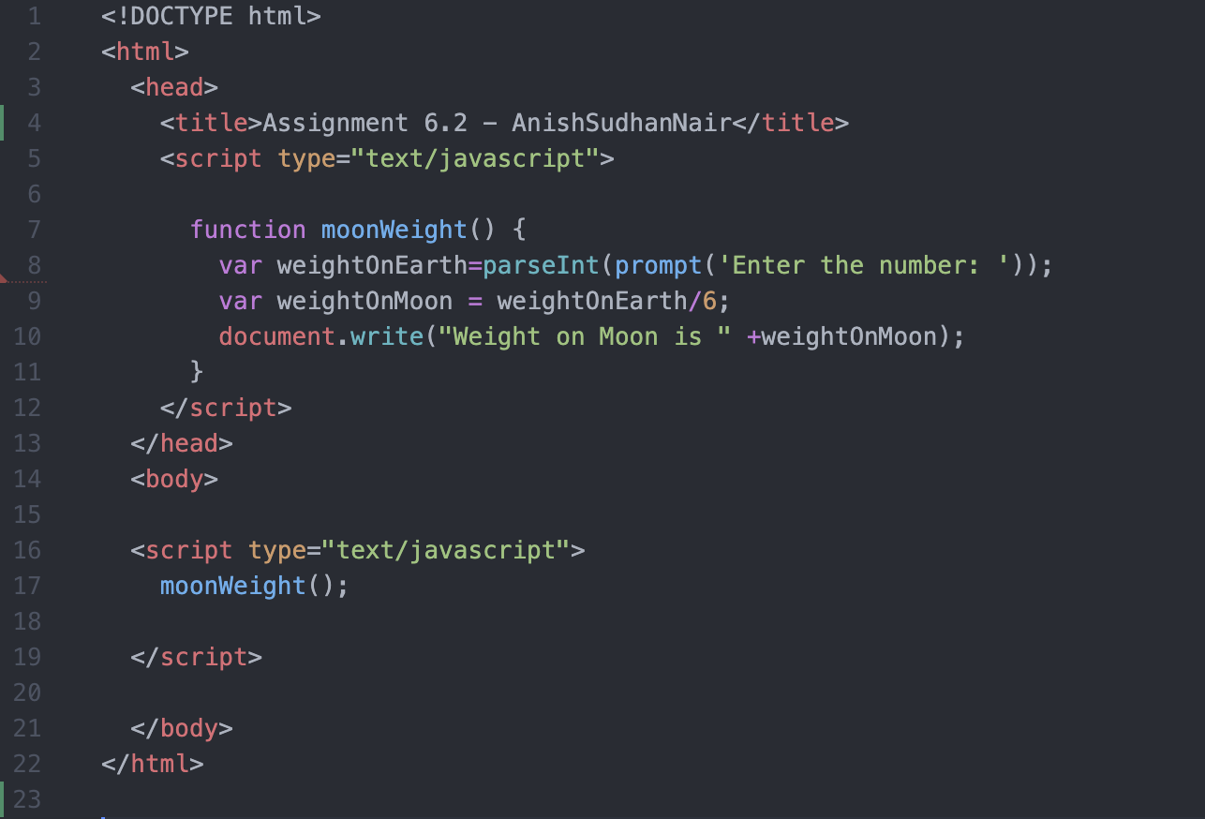

Output:

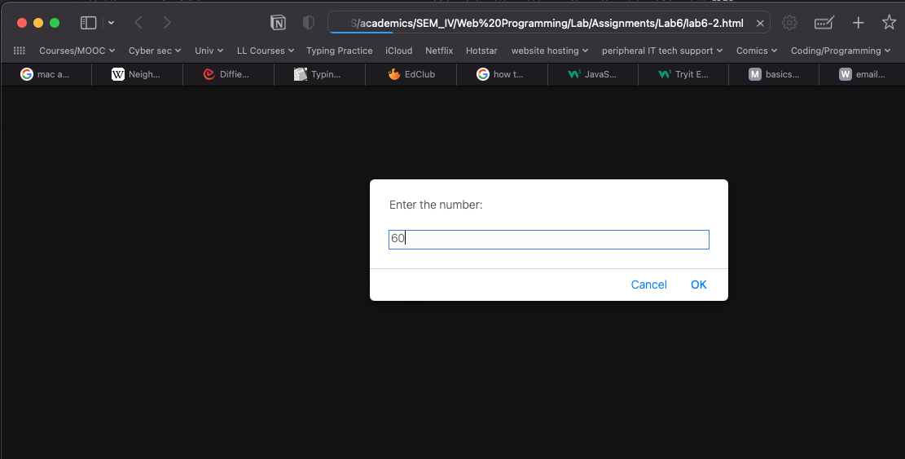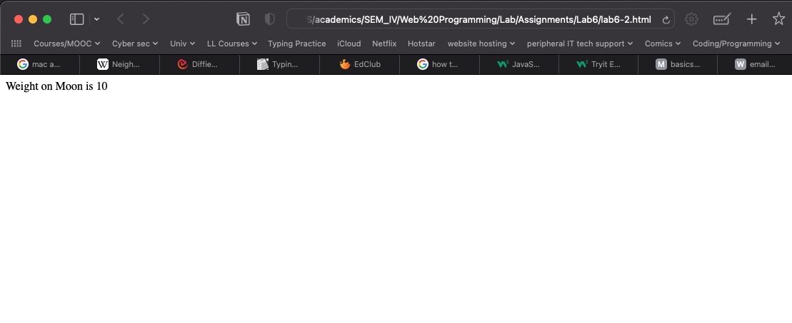

3. Write a java script program to create an Array for the students whose length is 5 . and display with ordered list.

Code:

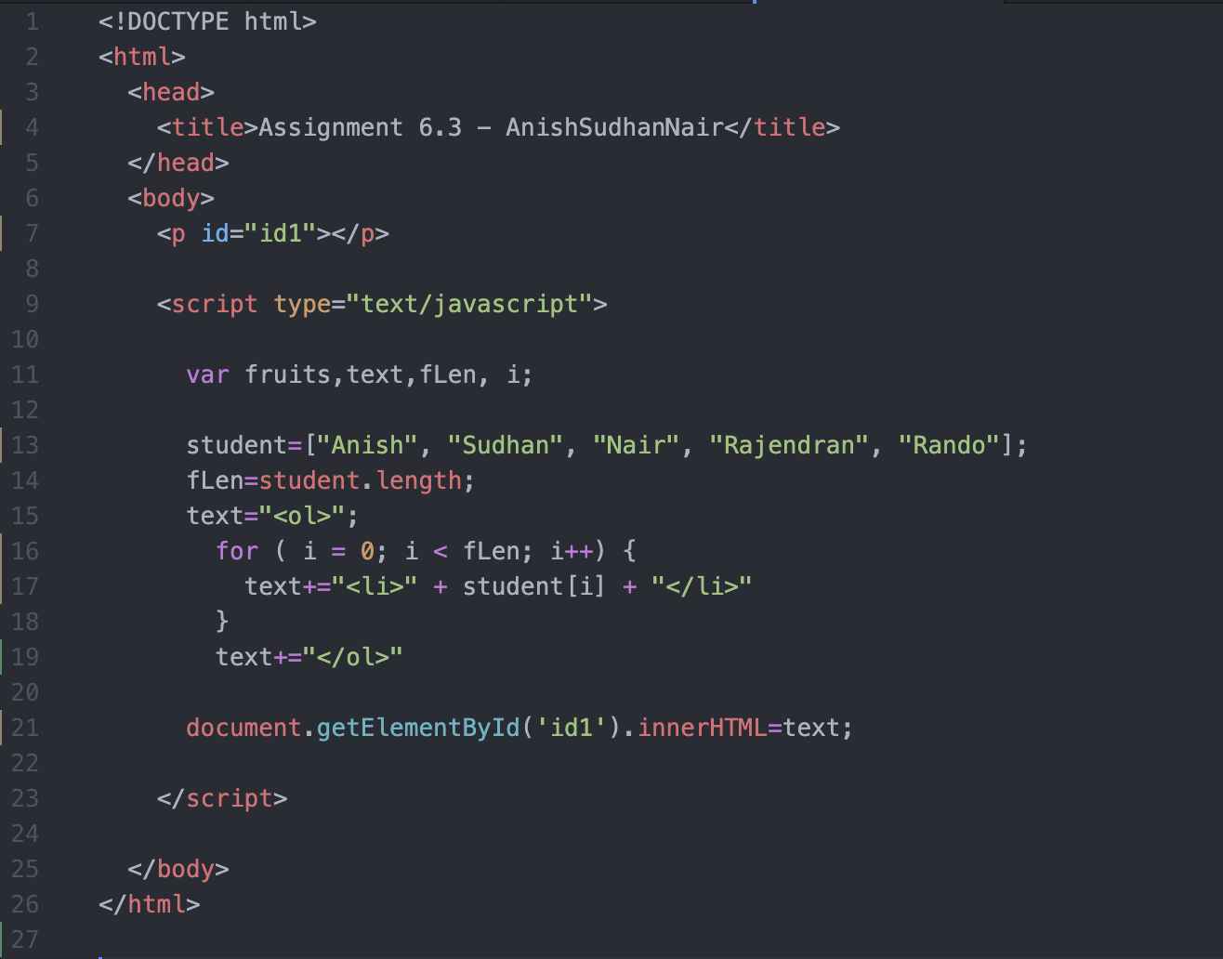

Output:

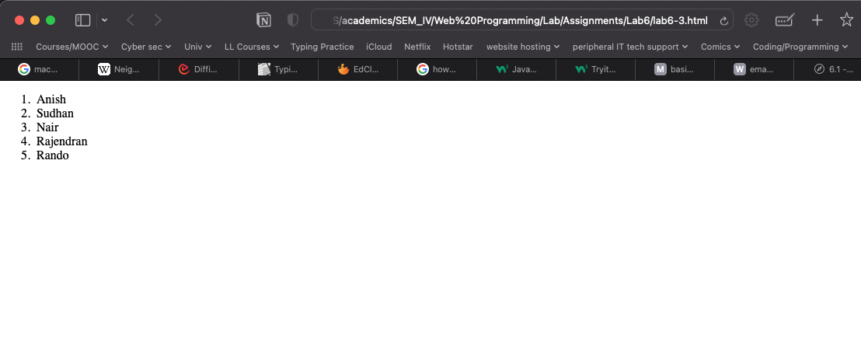

4. push the new students into an array and display the new array list on MouseOver Event on paragraph tags.

Code:

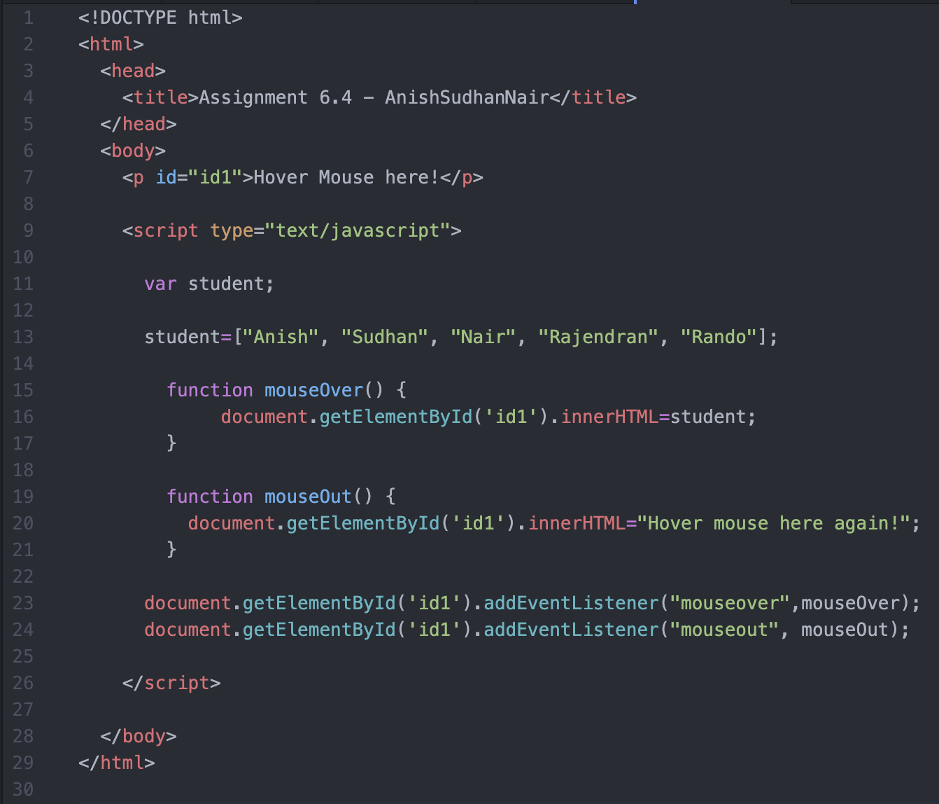

Output:

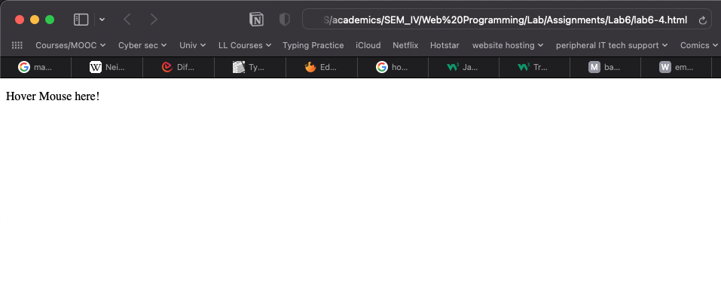

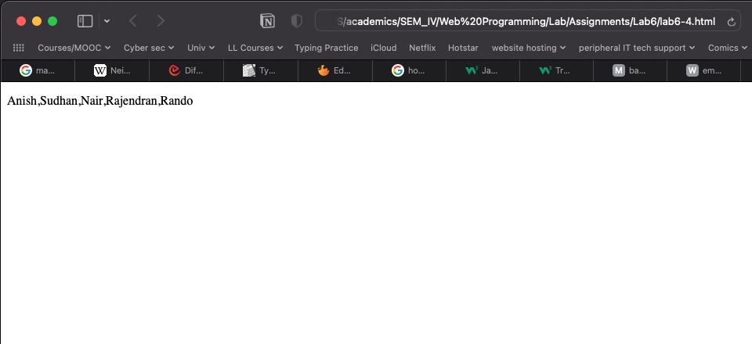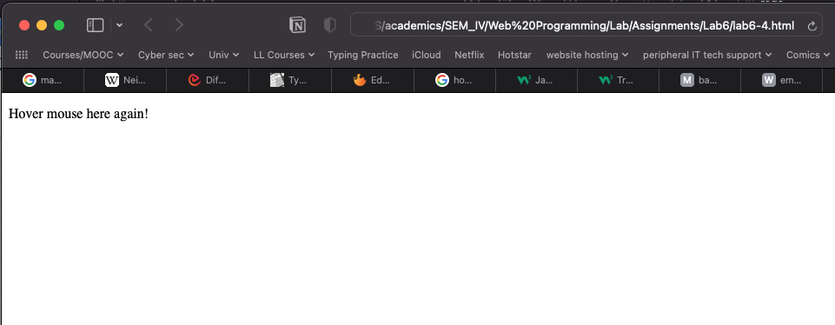

5. Splice ,new 3 students into an array on image Onclick Event.

Code:

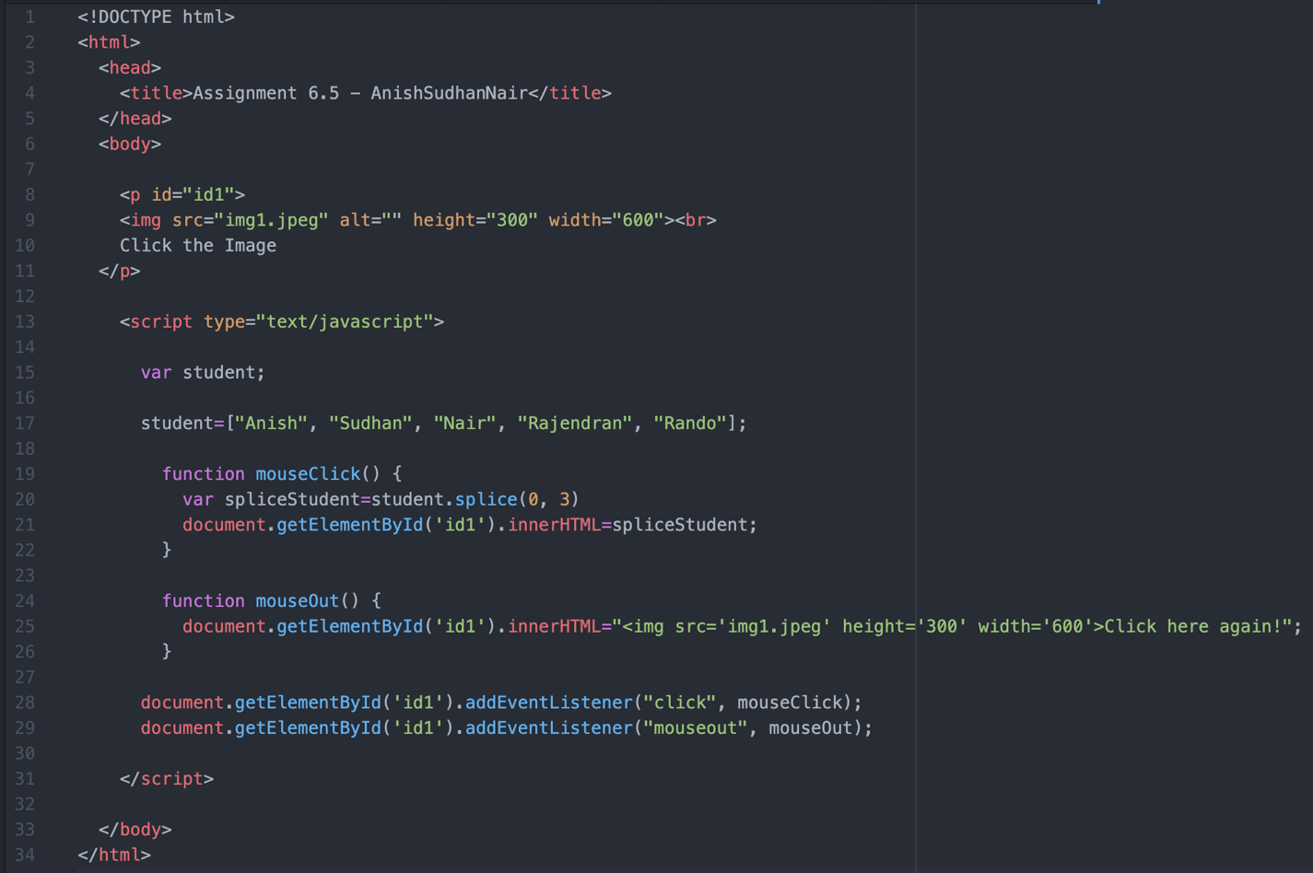

Output:

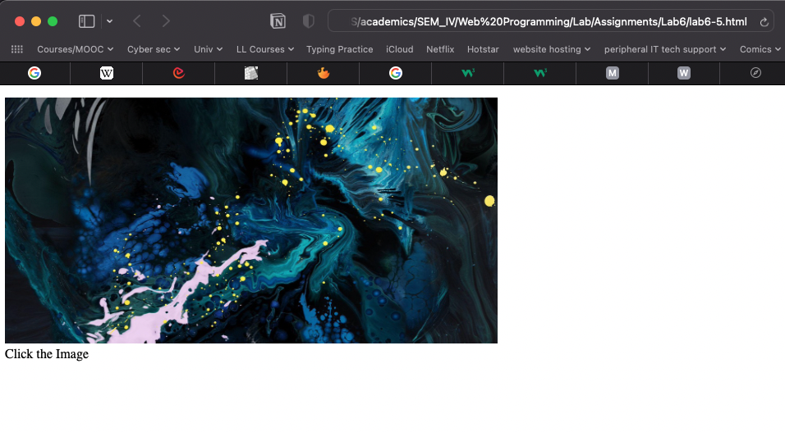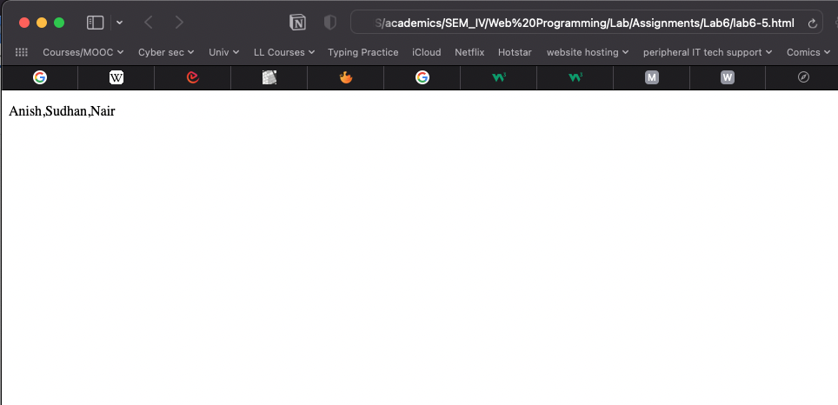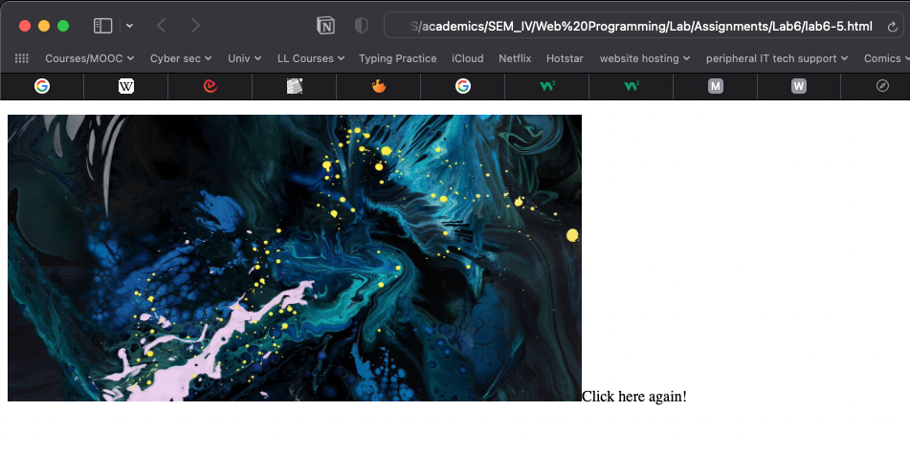

6. concate the two array called girls and boys students on division Onclick Event.

Code:

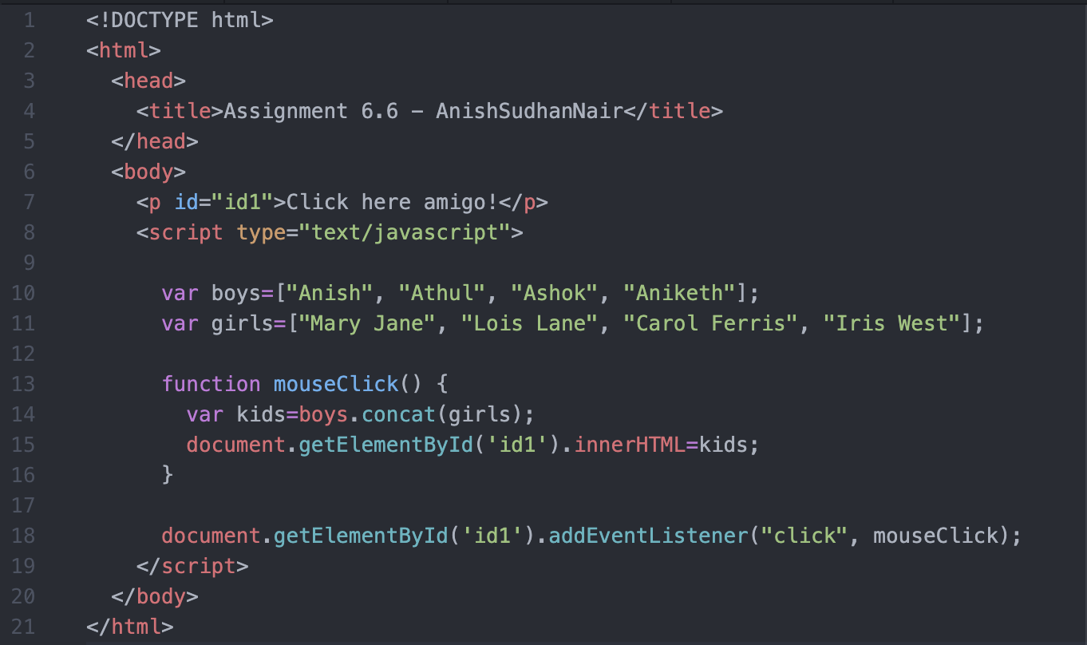

Output:

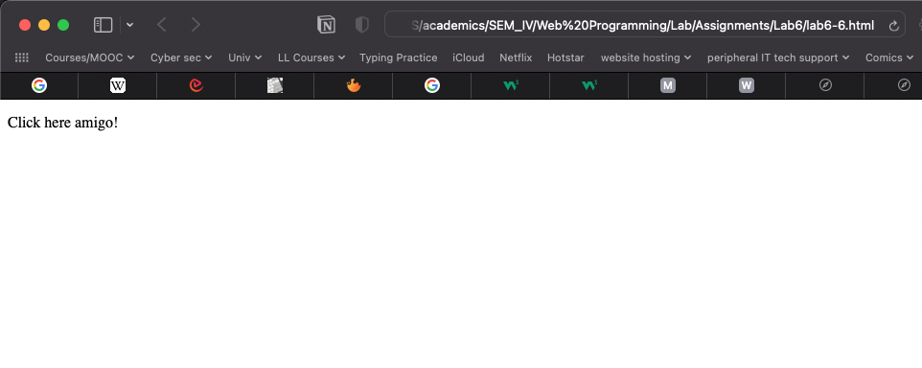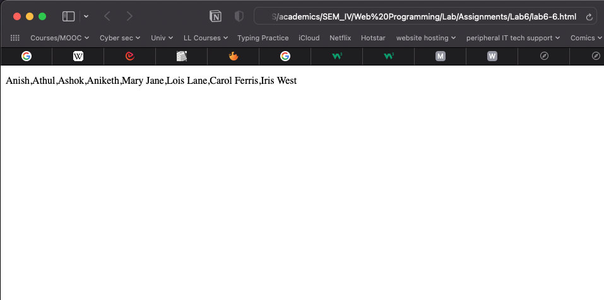

7. slice the students array into 3 halves using slice function of java Script.

Code:

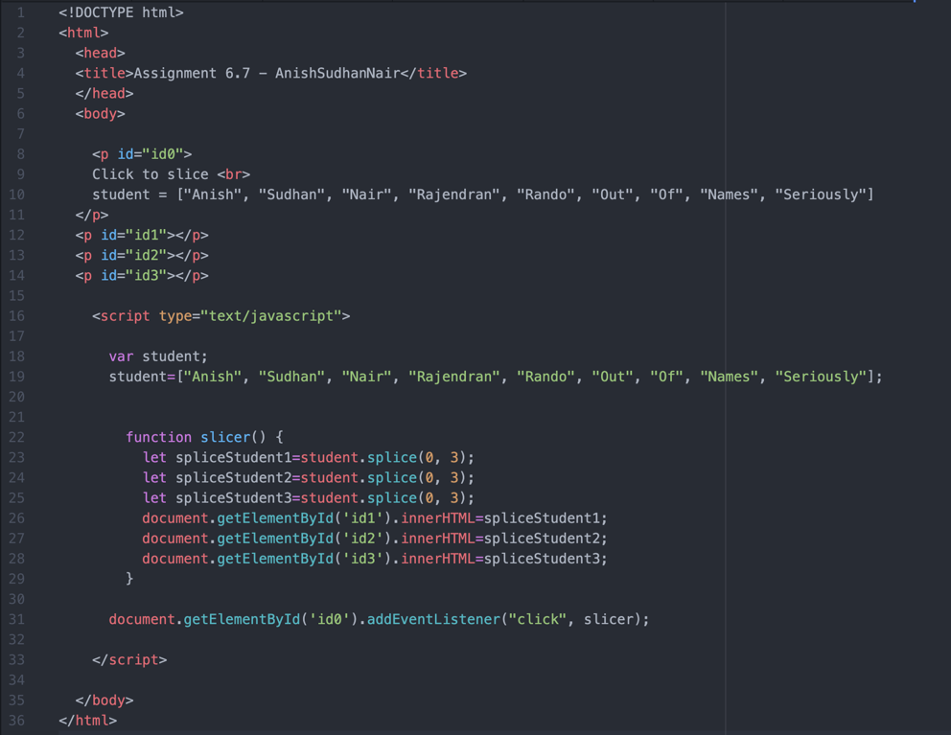

Output:

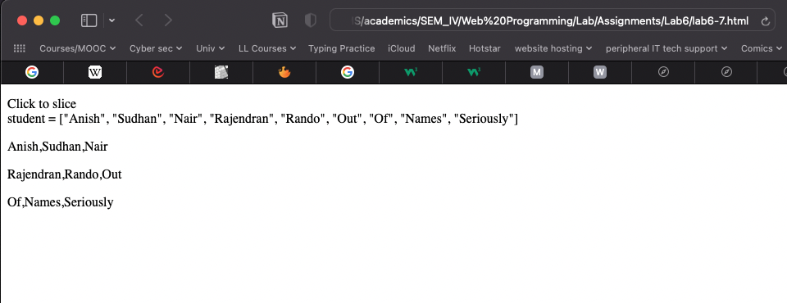

8. Validations 1

a. Write a Program to Accept User Name , User Age ,User Phone Number.

b. Check No user input is left or blank.

c. User Name length should be 10 char long.

d. User Age should be more than 20 and less than 90.

e. User Phone length should be 10 digit long.

f. Note:- User inner html for displaying an error message.

Code:

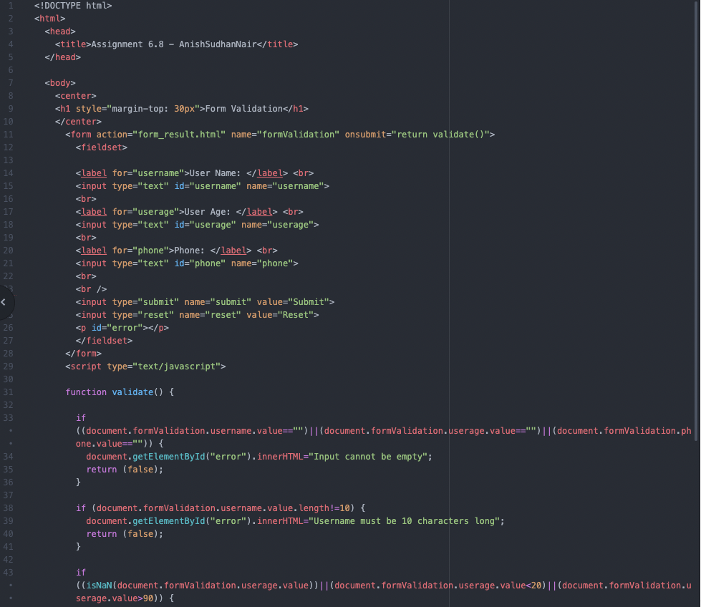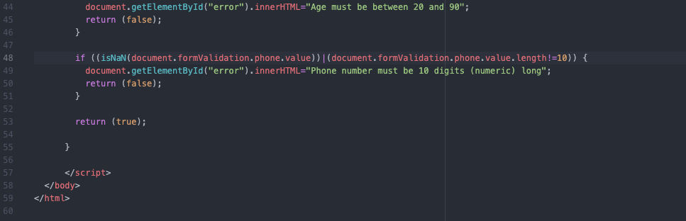

Output:

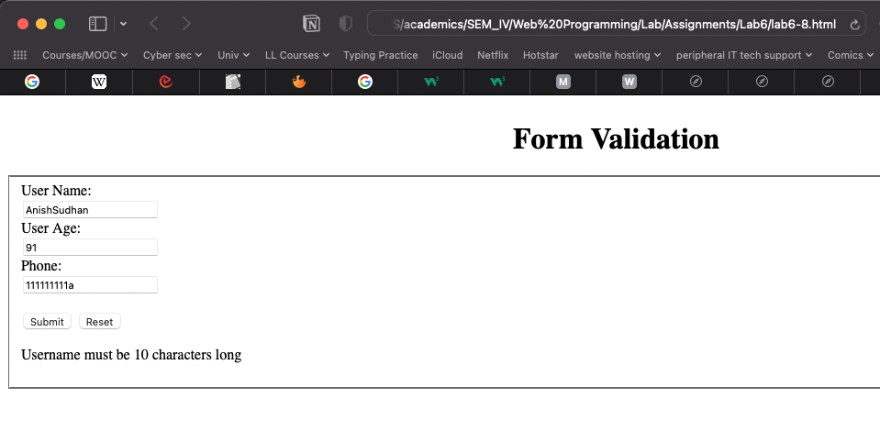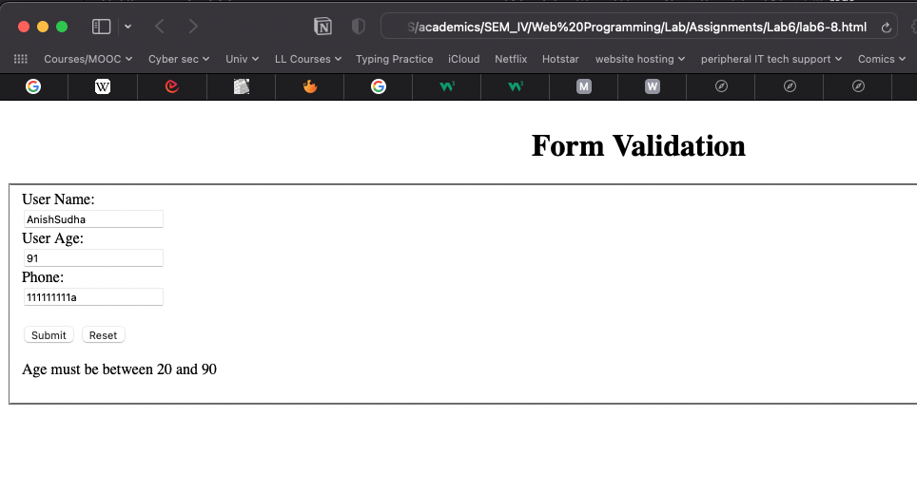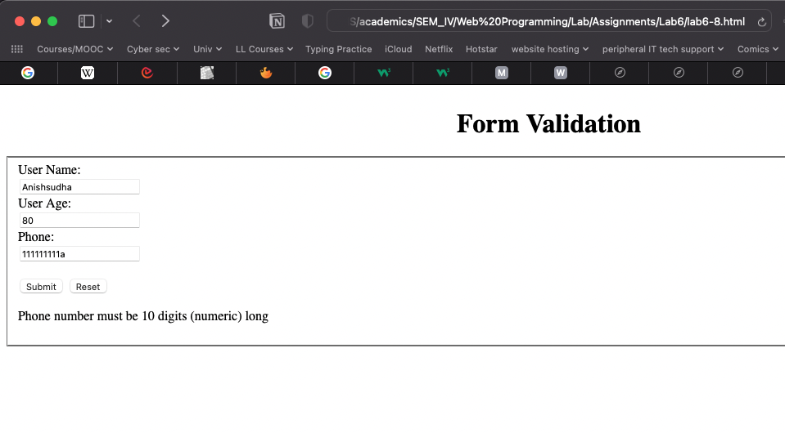

9. Form Validations 2

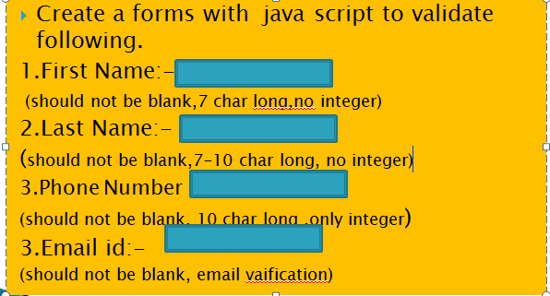

Code:

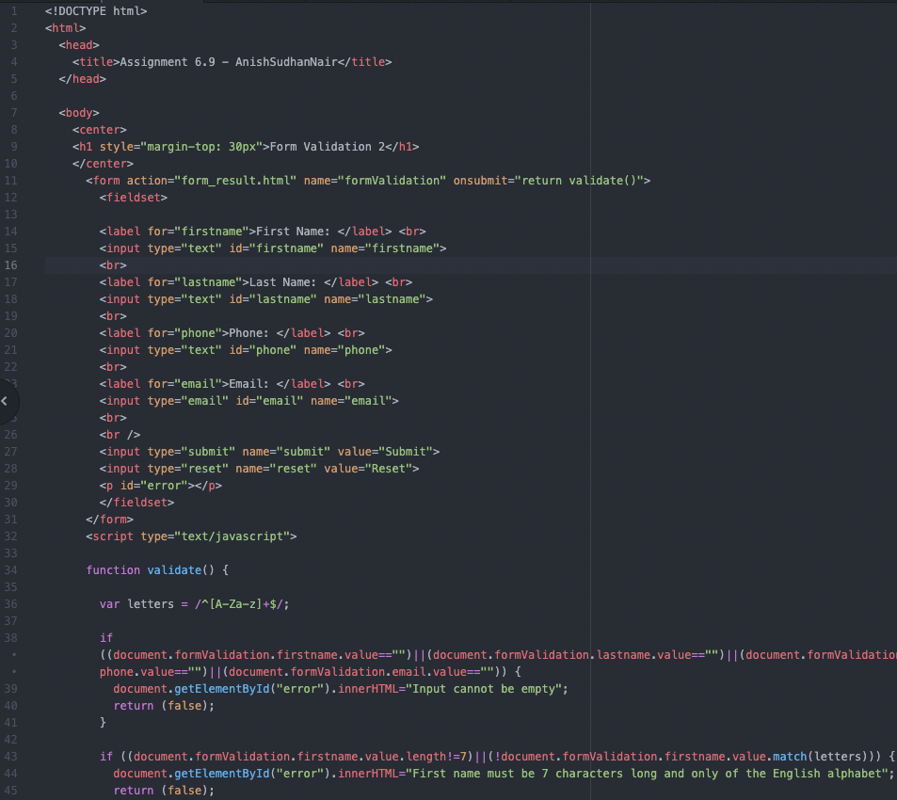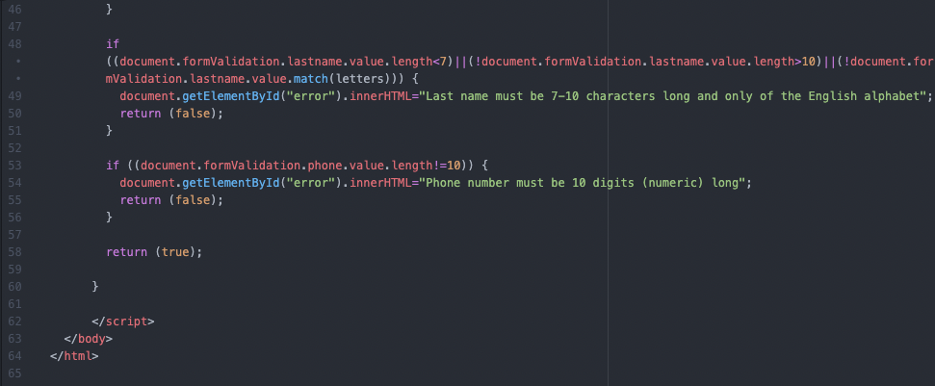

Output:

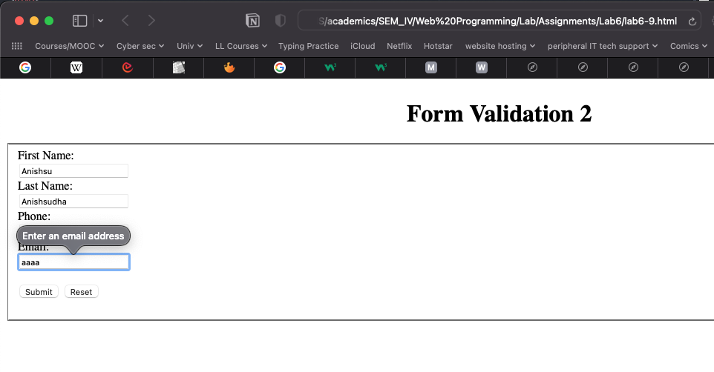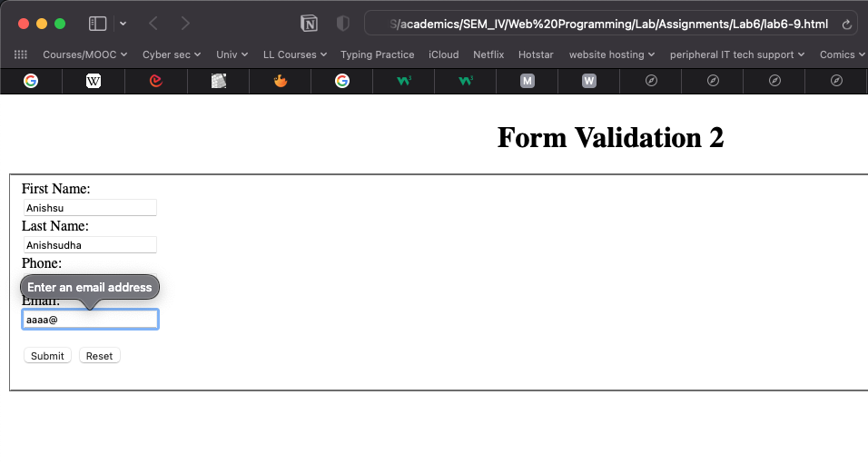

**observation and Learning:-**

We were introduced to more advanced functions of JavaScript, its functions and other syntax and means of incorporating within the codes of existing web pages made of CSS and HTML. We further learnt to write text and answers derived from logical arithmetic on the web page by using functions, arrays, array operations, form validations and such. JavaScript helps to greatly increase the functionality of a web page.

**Conclusion:-**

In this practical we learnt about more intermediate JavaScript and its implementation in web pages.

**Questions:-**

1. What is meaning of inner html?

innerHTML is used to interact with HTML elements from within JavaScript. It can be used to either return the content of an HTML element or set its content.

1. What is the meaning of DOM?

DOM which stands for Document Object Model is a tree structure of all the HTML elements in a web page that is created by the browser when the page is loaded. JavaScript therein uses the DOM to manipulate and interact with the HTML elements in that page.

1. What is JavaScript needed to be used in conjunction with HTML for building webpages?

The main advantage of using JavaScript in a webpage is the dynamic interaction that it allows for. It enables users to interact with the page without having to reload it every time and can update and data and manipulate the elements and front end in real time on interacting with the user. This, apart from increasing the functionality of the page, enables to make it look and feel better than a static HTML only web page.